

Task 5– Credit Submission

Student Name: Truong Ngoc Gia Hieu
Student Number (VietNam/Australia): SWS01217/ 105565520

Task Credit5a
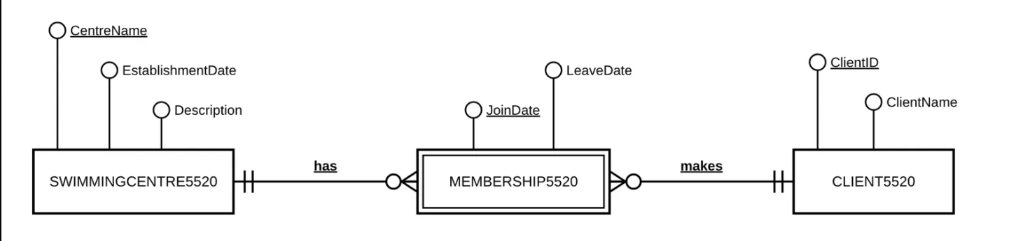
Figure 1: Entity Relationship Diagram (ERD) for Task Credit 5a.
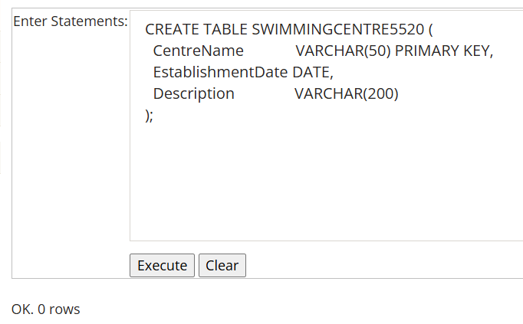
Figure 2: SQL statement for creating the SWIMMINGCENTRE5520 table.
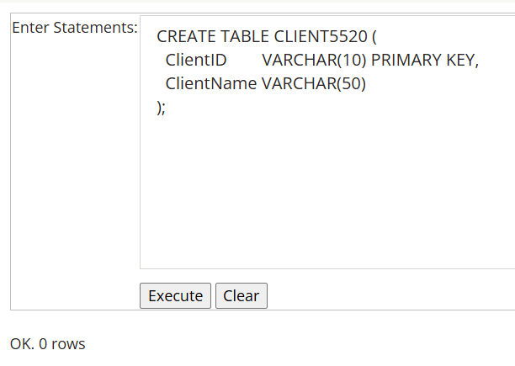
Figure 3: SQL statement for creating the CLIENT5520 table.
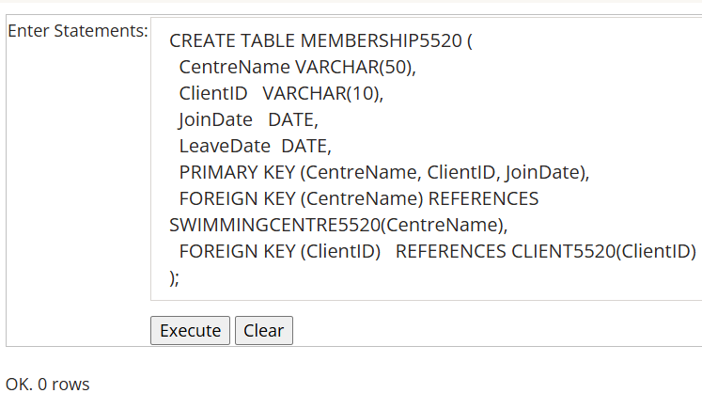
Figure 4: SQL statement for creating the MEMBERSHIP5520 table.
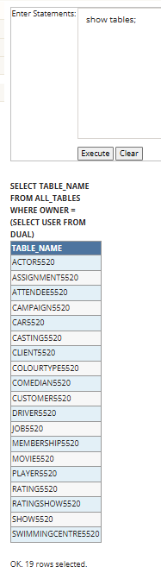
Figure 5: SQL statement for listing all created tables in the database.
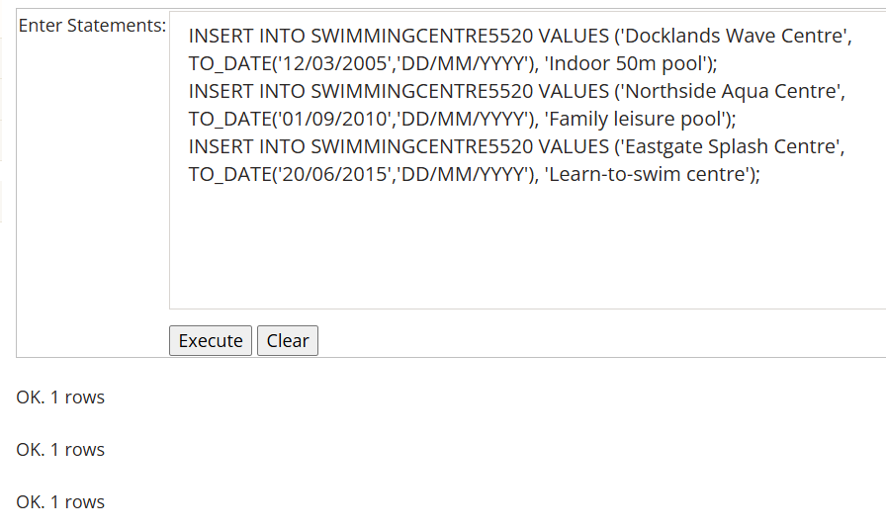
Figure 6: SQL statements for inserting records into the SWIMMINGCENTRE5520 table.
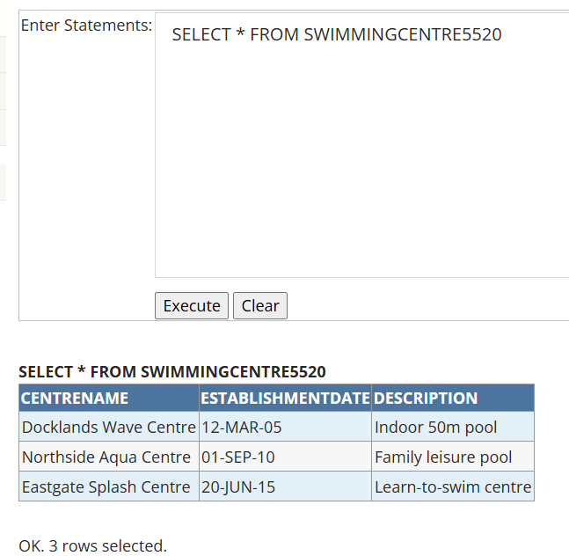
Figure 7: SQL query displaying all records in the SWIMMINGCENTRE5520 table.
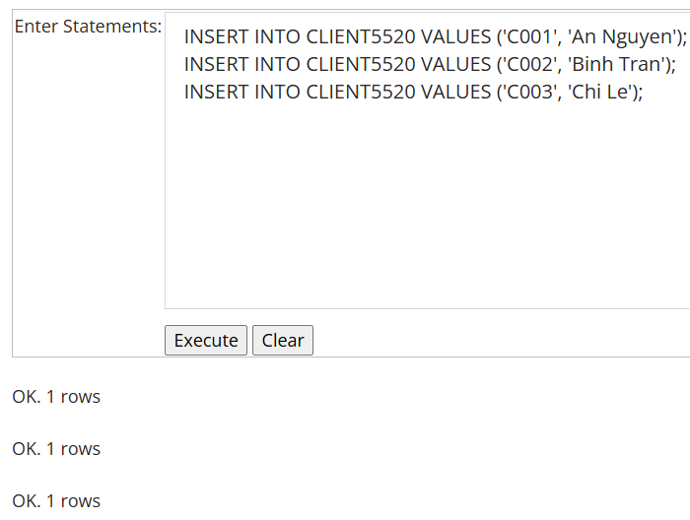
Figure 8: SQL statements for inserting records into the CLIENT5520 table.
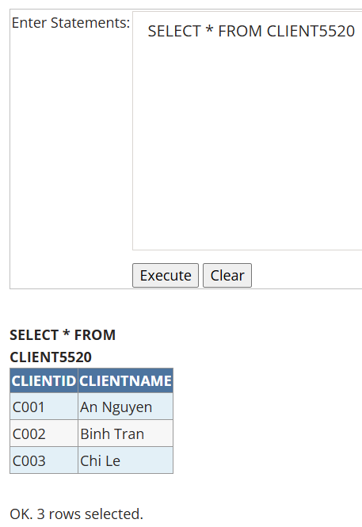
Figure 9: SQL query displaying all records in the CLIENT5520 table.
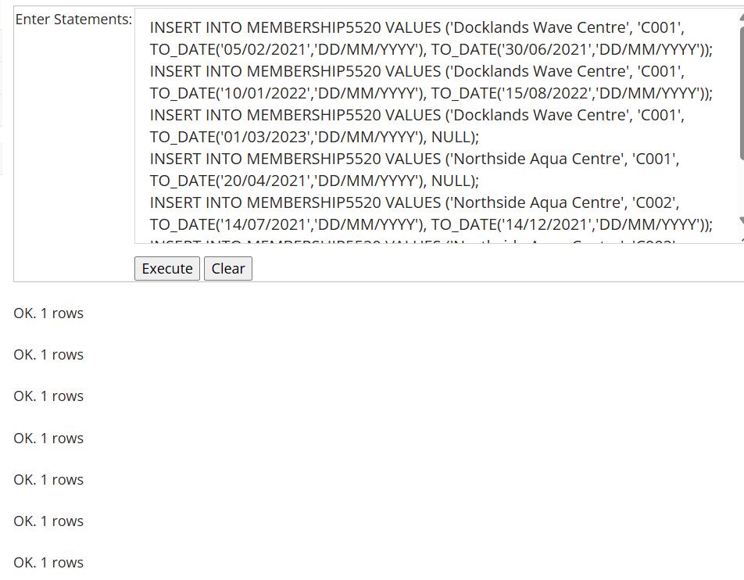
Figure 10: SQL statements for inserting records into the MEMBERSHIP5520 table.
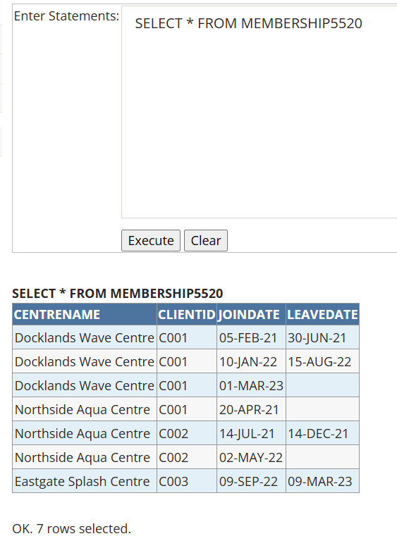
Figure 11: SQL query displaying all records in the MEMBERSHIP5520 table.

Task Credit5b
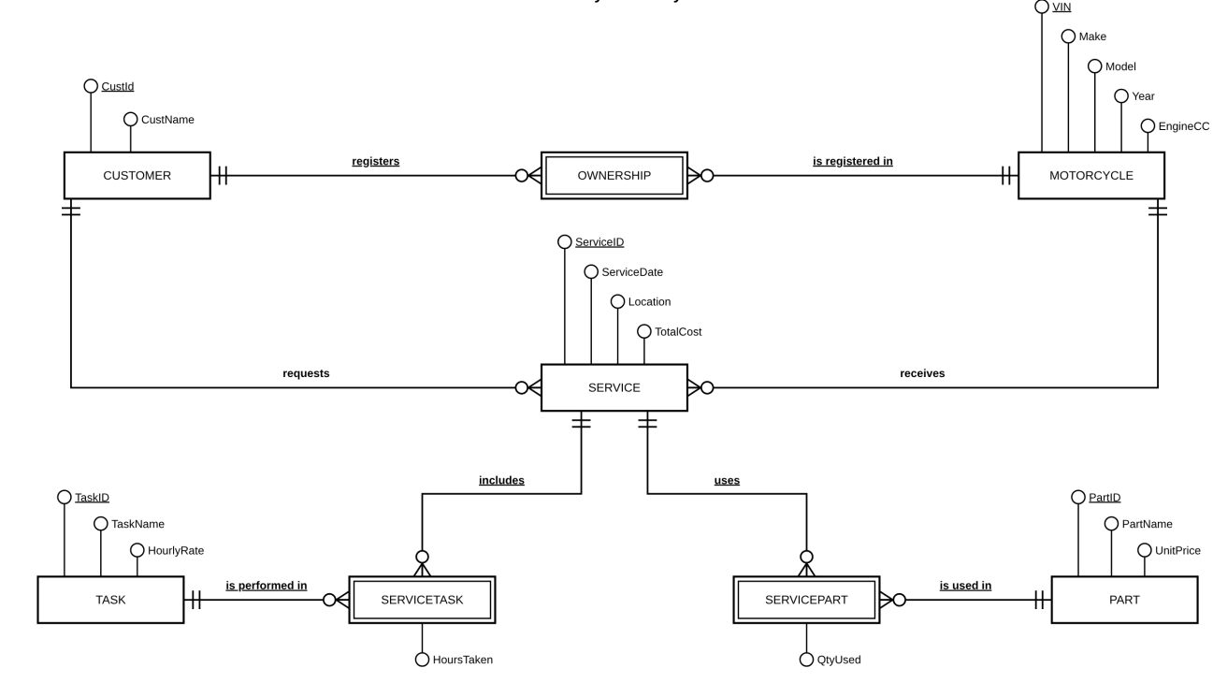
Figure 12: Entity Relationship Diagram (ERD) for Tiny’s Motorcycle Maintenance.

Task Credit5c
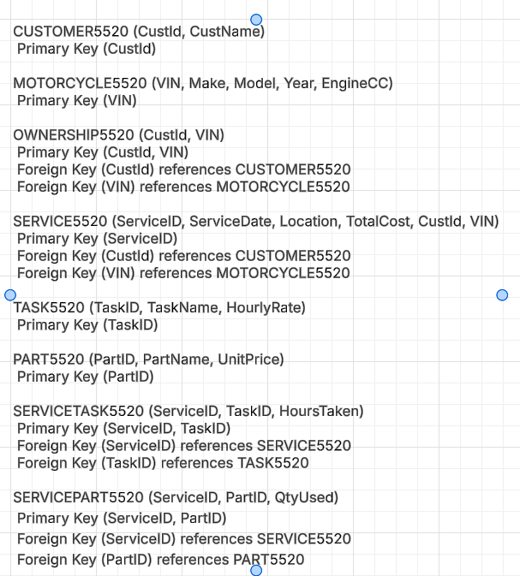
Figure 13: Relational Schema for Tiny’s Motorcycle Maintenance.

Task Credit5d
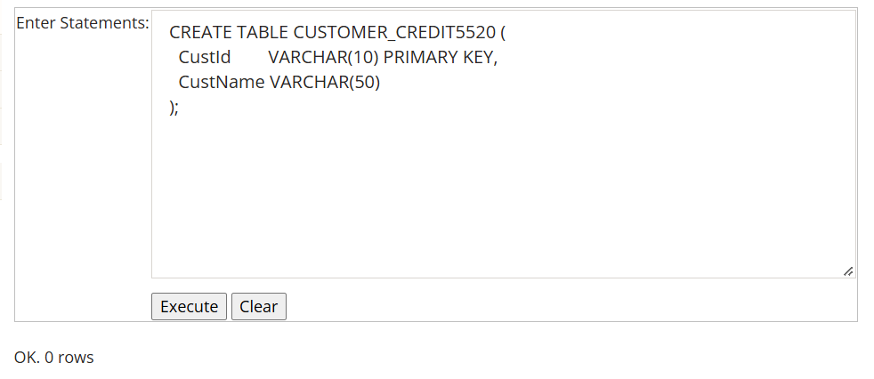
Figure 14: SQL statement for creating the CUSTOMER_CREDIT5520 table.
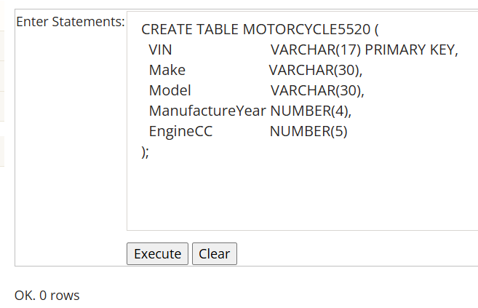
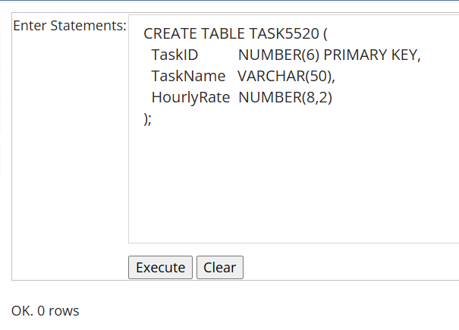
Figure 16: SQL statement for creating the TASK5520 table.
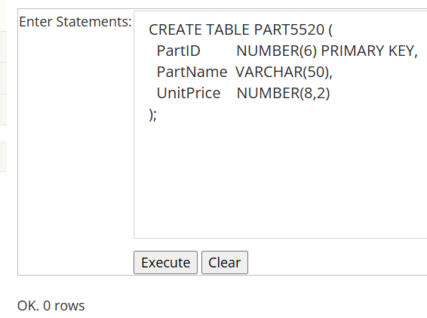
Figure 17: SQL statement for creating the PART5520 table.
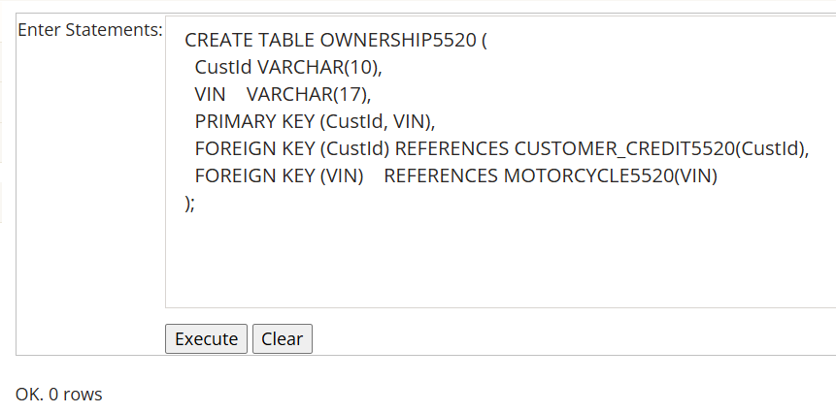
Figure 18: SQL statement for creating the OWNERSHIP5520 table.
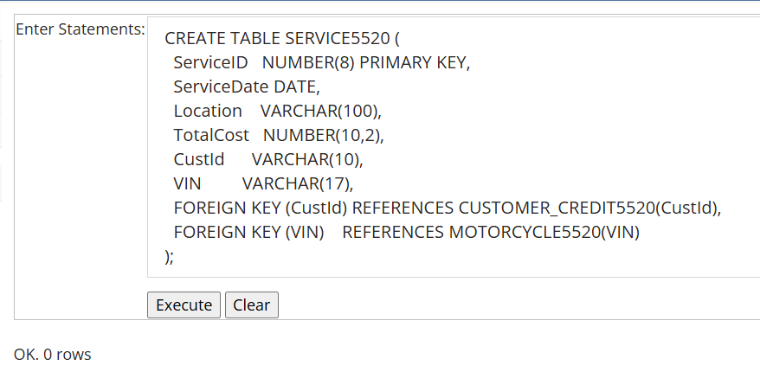
Figure 19: SQL statement for creating the SERVICE5520 table.
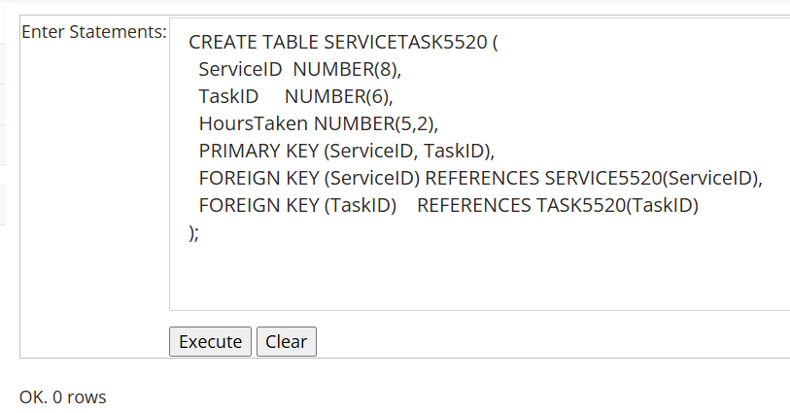
Figure 20: SQL statement for creating the SERVICETASK5520 table.
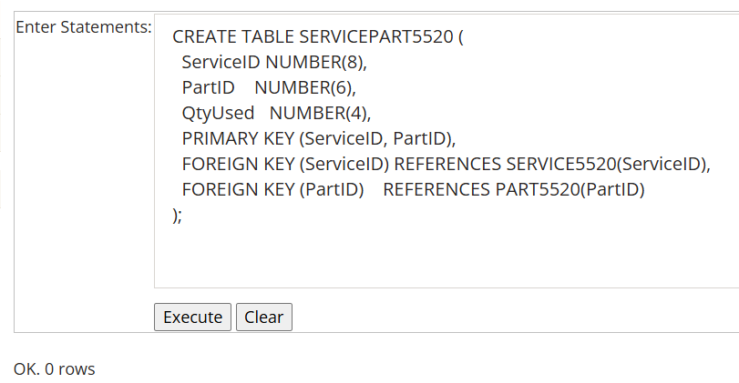
Figure 21: SQL statement for creating the SERVICEPART5520 table.
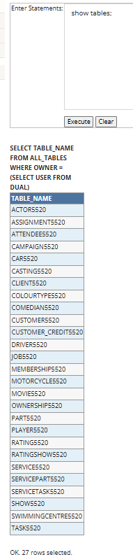
Figure 22: SQL statement for listing all created tables in the database after creating the Credit 5d tables.

Task Credit5e
The 1NF table from Pass 5e has the composite primary key (CustId, CarRego, StartDate). To reach 3NF, the partial dependencies were removed first: Name and Phone depend only on CustId, and MakeModel depends only on CarRego. After that, no transitive dependency remains, so every non-key attribute depends on the key, the whole key and nothing but the key.
CUSTOMER (CustId, Name, Phone)
CustId | Name | Phone
125 | John Coles | 0401112233
278 | Erin Trump | 0466121455
721 | Lynda Rodgers | 0423544117
Table 1: CUSTOMER relation in 3NF (primary key: CustId).
CAR (CarRego, MakeModel)
CarRego | MakeModel
1AU8HK | Mazda 3
1LM3AB | Hyundai i30
1KA2CA | Toyota Camry
1CZ8JK | Mazda 3
Table 2: CAR relation in 3NF (primary key: CarRego).
RENTAL (CustId, CarRego, StartDate, ReturnDate)
CustId | CarRego | StartDate | ReturnDate
125 | 1AU8HK | 31/08/2020 | 7/09/2020
125 | 1LM3AB | 14/11/2020 | 21/11/2020
278 | 1AU8HK | 12/09/2020 | 19/09/2020
278 | 1KA2CA | 1/10/2020 | 8/10/2020
278 | 1CZ8JK | 10/11/2020 | 12/11/2020
278 | 1AU8HK | 26/11/2020 | 1/12/2020
721 | 1LM3AB | 10/09/2020 | 13/09/2020
Table 3: RENTAL relation in 3NF (primary key: CustId, CarRego, StartDate; CustId references CUSTOMER and CarRego references CAR).

Task Credit5f
SQL statements to create the tables and insert the initial data
CREATE TABLE PRODUCT5520 (
ProdID VARCHAR(10) PRIMARY KEY,
Brand VARCHAR(30),
Description VARCHAR(100),
PricePerOne NUMBER(8,2),
QtyInStock NUMBER(5) CHECK (QtyInStock >= 0)
);

CREATE TABLE ACTION5520 (
ActionID NUMBER(6) PRIMARY KEY,
ActionDateTime DATE,
ActionType VARCHAR(20),
ProdID VARCHAR(10),
ProdQty NUMBER(5),
ProdCost NUMBER(10,2),
FOREIGN KEY (ProdID) REFERENCES PRODUCT5520(ProdID)
);

INSERT INTO PRODUCT5520 VALUES ('G43546', 'Gucci', 'Leather mid-heel pump', 1050.00, 12);
COMMIT;

Transaction 1 - Purchase (ActionID 1008)
INSERT INTO ACTION5520 VALUES (1008, TO_DATE('21/01/2021','DD/MM/YYYY'), 'Purchase', 'G43546', 2, 2100.00);
UPDATE PRODUCT5520 SET QtyInStock = QtyInStock - 2 WHERE ProdID = 'G43546';
COMMIT;

Transaction 2 - Return (ActionID 1026)
INSERT INTO ACTION5520 VALUES (1026, TO_DATE('23/01/2021','DD/MM/YYYY'), 'Return', 'G43546', -1, 1050.00);
UPDATE PRODUCT5520 SET QtyInStock = QtyInStock - (-1) WHERE ProdID = 'G43546';
COMMIT;

Checking the result (QtyInStock should be 12 - 2 + 1 = 11)
SELECT * FROM PRODUCT5520;
SELECT * FROM ACTION5520;

A failed transaction and ROLLBACK (purchase of 50 pairs when only 11 are in stock)
INSERT INTO ACTION5520 VALUES (1030, TO_DATE('25/01/2021','DD/MM/YYYY'), 'Purchase', 'G43546', 50, 52500.00);
UPDATE PRODUCT5520 SET QtyInStock = QtyInStock - 50 WHERE ProdID = 'G43546'; -- fails: ORA-02290 (check constraint)
ROLLBACK;

Explanation
From my perspective, a sale or a refund goes smoothly when every step of the transaction succeeds. For a purchase, the system records a new row in the ACTION table and then reduces QtyInStock in the PRODUCT table. Similarly, for a return, it records a negative quantity and increases the stock. As a result, the two tables stay consistent, and the transaction is "committed", which means that the changes are saved permanently and become visible to other users.
However, an operation can go wrong if one step fails while the other succeeds, for example when the customer buys more pairs than the stock level allows, or when the system crashes after the ACTION row is inserted but before the stock is updated. Without protection, this would leave the transaction history and the stock level out of agreement. In this case, the transaction is "rolled back", which means that all changes made since the transaction started are undone and the database returns to its previous consistent state. Therefore, a transaction works as an all-or-nothing unit, which protects the accuracy of the data.

